Appendix A
Treasury Management Activity 2nd Report 2015-16

- Background
The County Council’s Treasury Management activity is underpinned by CIPFA’s Code of Practice on Treasury Management (“the Code”), which requires authorities to produce annually Prudential Indicators and a Treasury Management Strategy Statement on the likely financing and investment activity. The Code also recommends that members are informed of treasury management activities at least twice a year.

This report considers treasury management activity between 1st August 2015 and 30th November 2015.

- Economic Context in the period

Domestic demand has grown robustly, supported by sustained real income growth and a gradual decline in private sector savings. Low oil and commodity prices contributed to annual CPI inflation falling to 0.1% in October. Wages are growing at 3% a year, and the unemployment rate has dropped to 5.4%. Mortgage approvals have risen to over 70,000 a month and annual house price growth is around 3.5%. These factors have boosted consumer confidence, helping to underpin retail spending and hence GDP growth, which was an encouraging 2.3% a year in the third quarter of 2015. Although speeches by the Bank of England’s Monetary Policy Committee (MPC) members sent signals that some were willing to countenance higher interest rates, the MPC held policy rates at 0.5% for the 81st consecutive month at its meeting in November 2015. Quantitative easing (QE) has been maintained at £375bn since July 2012.
In international markets China's growth has slowed and its economy is performing below expectations, reducing global demand for commodities and contributing to emerging market weakness. US domestic growth has accelerated but the globally sensitive sectors of the US economy have slowed. Strong US labour market data and other economic indicators however suggest recent global turbulence has not knocked the American recovery off course. The Federal Reserve did not raise policy rates at its meetings in October and November, but the statements accompanying the policy decisions point have made a rate hike in December 2015 a real possibility. In contrast, the European Central Bank finally embarked on QE in 2015 to counter the perils of deflation.

2.1 Interest Rate Environment

The Authority’s treasury advisor Arlingclose projects the first 0.25% increase in UK Bank Rate in the third quarter of 2016, rising by 0.5% a year thereafter, finally settling between 2% and 3% in several years’ time. Persistently low inflation, subdued global growth and potential concerns over the UK’s position in Europe mean that the risks to this forecast are weighted towards the downside.
A shallow upward path for medium term gilt yields is forecast, as continuing concerns about the Eurozone, emerging markets and other geo-political events weigh on risk appetite, while inflation expectations remain subdued. Arlingclose projects the 10 year gilt yield to rise from its current 2.0% level by around 0.3% a year. The uncertainties surrounding the timing of UK and US interest rate rises are likely to prompt short-term volatility in gilt yields.
2.2 Implications for Lancashire County Council Treasury Strategy

Since 2010 the County Council have used short term market borrowing to fund capital expenditure so taking advantage of historically low interest rates. This policy has proved to be very effective in an environment where rates have stayed low for much longer than expected and continue to do so. Prospects for interest rate increases are continuously monitored and flexible arrangements are maintained to enable the Council to react in good time should the path of interest rate forecasts change.

3. Current Treasury Management Policy
Full Council approved the 2015/16 treasury management strategy at its meeting on 12th February 2015. The County Council’s stated Treasury Management objectives are:

a) To ensure the security of the principal sums invested which represent the County Council's various reserves and balances,
b) To ensure that the County Council has access to cash resources as and when required,
c) To minimise the cost of the borrowing required to finance the County Council's capital investment programme, and
d) To maximise investment returns commensurate with the County Council's policy of minimising risks to the security of capital and its liquidity position.

3.1 Investment Activity

Investments at the 30th November are £769.18m consisting of £188.07m in bank and Local Authority deposits and £581.11m in bonds. In total investments have increased by £57.25m over the period. The table below shows the investment activity between 1st August 2015 and 30th November 2015.

Bank and Local Authority | Call/MMF | Fixed | Structured | Total
Deposits | £m | £m | £m | £m
Balance 1 August 2015 | 80.85 | 56.50 | 39.46 | 176.81
Maturities | -56.01 | 0.00 | 0.00 | -56.01
New Investments | 66.95 | 0.00 | 0.33 | 67.28
Balance 30 November 2015 | 91.79 | 56.50 | 39.79 | 188.07
Bonds | LA Bonds | Gilts | Others | Total
 | £m | £m | £m | £m
Balance 1 August 2015 | 36.29 | 294.28 | 204.56 | 535.13
Maturities | -0.22 | -554.21 | -163.92 | -718.35
New Investments | 0.18 | 445.23 | 318.93 | 764.33
Balance 30 November 2015 | 36.24 | 185.29 | 359.57 | 581.11

Bail-in legislation, which ensures that large investors including local authorities will rescue failing banks instead of taxpayers in the future, has now been fully implemented in the UK, USA and Germany. The rest of the European Union will follow suit in January 2016, while Australia, Canada and Switzerland are well advanced with their own plans. Meanwhile, changes to the UK Financial Services Compensation Scheme and similar European schemes in July 2015 mean that most private sector investors are now partially or fully exempt from contributing to a bail-in. The credit risk associated with making unsecured bank deposits has therefore increased relative to the risk of other investment options available to the Authority.
This is the reason LCC no longer invests in unsecured term bank deposits. The final investment of the type is the structured loan of £39.79m shown in the table below. This deposit matured on 7th December 2015 and at the time of writing has been repaid. The remaining fined deposits are all with other local authorities.
Within the period, there has been a decrease of £109m in the amount of Gilts being held with a corresponding increase in other bonds of £155m. This portfolio rebalancing is in response to market changes and the additional bond investments have been in liquid securities, principally floating rate notes to protect advance short term borrowing against interest rate risk. There has been no reduction of the overall credit quality of the portfolio

The current rate of return on the investment portfolio measured by Arlingclose Ltd treasury consultants is 1.36% which compares favourably with the benchmark 7 day LIBID which averages 0.46% over the same period.

3.2 Borrowing Activity

Current market conditions continue to enable the County Council to take advantage of short term market borrowing. The table below shows the borrowing activity which has taken place between 1st August 2015 and 30th November 2015.

Borrowing | PWLB Fixed | PWLB Variable | Long Term Market Loan | Other Locals | Police, Fire & Lancashire District Councils | Total
 | £m | £m | £m | £m | £m | £m
Balance 1 August 15 | 213.10 | 125.75 | 52.23 | 566.90 | 104.93 | 1,062.91
Maturities | 0.00 | 0.00 | -0.45 | -133.40 | -124.00 | -257.84
New Borrowing | 0.00 | 0.00 | 0.00 | 199.90 | 114.85 | 314.75
Balance 30 November 2015 | 213.10 | 125.75 | 51.78 | 633.40 | 95.78 | 1,119.81
Public Finance Initiative (PFI) Liability | - | - | - | - | - | 172.00
Total Borrowing  & PFI |  |  |  |  |  | 1,291.81

The outstanding borrowing has increased by £56.90m in the period. The increase in borrowing reflects the re-financing of deals maturing in the near future in order to take advantage of current low interest rate offers from other Local Authorities and before liquidity dries up approaching the holiday period.

Total borrowing now stands at £1.292bn including the financing of £172m of assets through remaining non-waste PFI schemes.

The majority of the maturing borrowing for the current financial year has now been replaced with only around £20m outstanding before 31st March 2016.
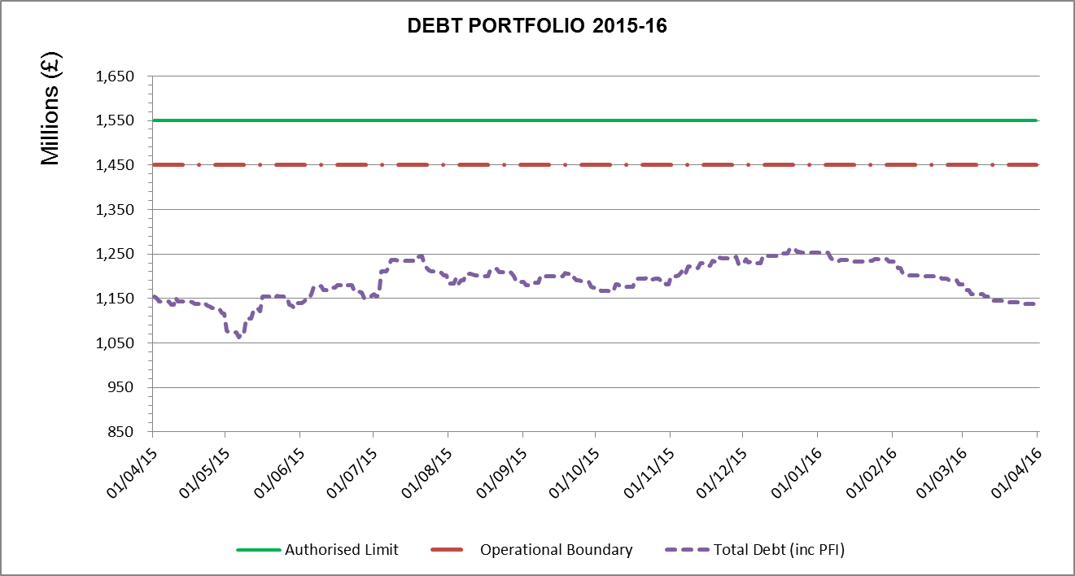

The graph above shows the level of debt for the current financial year compared with the prudential indicator operational and authorised boundaries. The debt shown from 30th November represents the debt position if no maturing debt was replaced rather than an estimate of the expected position.

The Authorised Limit is a prudent estimate of debt which reflects the Authority's capital expenditure plans and allows sufficient headroom for unusual cash movements.

The Operational Boundary is a prudent estimate of debt but no provision for unusual cash movements. It represents the estimated maximum external debt arising as a consequence of the County Council's current plans.

Total debt during the year has remained below the Operational Boundary.
The current interest rate payable on debt measured by Arlingclose Ltd treasury consultants is 1.649%. The most recent benchmarking figure available of the average rate for all Arlingclose clients (as measured on 31st March 2015) is 4.13%.

4. Budget Monitoring Position

The net financing charges budget for 2015/16 is forecasted to be £12m lower than budget at the end of the financial year. The reasons for this are:

- The refinancing of the waste recycling centres was initially anticipated to be repaid on a straight line basis. However, the decision has been taken to make the repayment on an annuity basis. This has resulted in a reduced Minimum Revenue Provision (MRP) of some £5.6m. It is estimated to be a similar amount for the next two years.

- When calculating the estimated MRP it was planned to apply up to £39m of borrowing in 2014/15. Due to the re-phasing of the Capital Programme this borrowing was not required thereby reducing requirement to charge the MRP in 2015/16.

- Higher than budgeted interest received of £8.038m is primarily due to the increased value of the County Council's low risk investment portfolios following market movements during recent months. This enabled some core Gilt bonds to be sold resulting in a net gain of £2.960m. There have also been additional gains of £5.078m resulting from sales of traded bonds again due to the volatility of the market.

- The saving on the MRP and higher than budgeted income received are offset by the agreed contribution towards the Todmorden Curve Rail project of £2.300m which was not in the original budget.

This position is kept under regular review taking account both of ongoing performance and also market movements and the forecast is provided to the Interim Director of Financial Resources on a monthly basis.

5. Prudential Indicators 2015/16
The Local Government Act 2003 and supporting regulations require the County Council to have regard to the prudential code and to set prudential indicators to ensure the County Council's capital investment plans are affordable, prudent and sustainable.

The County Council are within the Prudential Indicators as detailed in Annex 1.

Annex 1
Prudential Indicators

1. Adoption of CIPFA Treasury Management Code of Practice | Adopted
2. Authorised limit for external debt  A prudent estimate of debt which reflects the Authority's capital expenditure plans and allows sufficient headroom for unusual cash movements | 2015/16 | 30th November Actual
The Authorised Limit is a prudent estimate of debt which reflects the Authority's capital expenditure plans and allows sufficient headroom for unusual cash movements.
 | £m | £m
Borrowing | 1,300 | 1,120
Other long term liabilities (PFI schemes) | 250 | 172
TOTAL | 1,550 | 1,292
3. Operational boundary for external debt | 2015/16 | 30th November Actual
The Operational Boundary is a prudent estimate of debt but no provision for unusual cash movements. It represents the estimated maximum external debt arising as a consequence of the County Council's current plans.
 | £m | £m
Borrowing | 1,250 | 1,120
Other long term liabilities (PFI schemes) | 200 | 172
TOTAL | 1,450 | 1,292
4. Capital Financing Requirement to Gross Debt | 2015/16 | 30th November Actual
The Capital Financing requirement is the underlying need to borrow for capital purposes. This is the cumulative effect of past borrowing decisions and future plans. This is not the same as the actual borrowing on any one day, as day to day borrowing requirements incorporate the effect of cash flow movements relating to both capital and revenue expenditure and income.
 | £m | £m
Capital Financing Requirement | 861 | 830
Estimated gross debt | 1,010 | 1,120
Debt to Capital Financing Requirements | 117% | 135%
Gross borrowing is higher than the capital financing requirement because the shared investment scheme is accounted for as borrowing but it does not form part of the capital financial requirement calculation.

The County Council confirms that it has complied with its Prudential Indicators for 2015/16 which were approved on 26th February 2015 as part of the County Council's Treasury Management Strategy Statement.

Treasury Management Indicators

1. Interest Rate exposure |  |  |  | Upper Limit |  | Actual
The limit measures the County Council's exposure to the risk of interest rate movements. The one year impact indicator calculates the theoretical impact on the revenue account of an immediate 1% rise in all interest rates over the course of one financial year.
 |  |  |  | £m |  | £m
Net Interest Payable – Fixed Rate |  |  |  | 50.40 |  | 6.70
Net Interest Payable – Variable Rate |  |  |  | 5.00 |  | 1.30
1 year impact of a 1% rise |  |  |  | 10.00 |  | 0.70
2. Maturity structure of debt |  | Lower Limit % |  | Upper Limit % |  | Actual %
The limit on the maturity structure of debt helps control refinancing risk.
Under 12 months |  | - |  | 75 |  | 21
12 months and within 2 years |  | - |  | 75 |  | 36
2 years and within 5 years |  | - |  | 75 |  | 17
5 years and within 10 years |  | - |  | 75 |  | 6
10 years and above |  | 25 |  | 100 |  | 20
3. Investments over 364 days |  |  |  | Upper Limit |  | Actual
The limit on the level of long term investments helps to control liquidity, although the majority of these investments are held in available for sale securities.
 |  |  |  | £m |  | £m
Total invested over 364 days |  |  |  | 900 |  | 568
4. Minimum Average Credit Rating |  |  |  | Benchmark |  | Actual
To control credit risk the County Council requires a very high credit rating from its treasury counterparties.
Average counterparty credit rating |  |  |  | A+ |  | AA+

